PROJECT REPORT

MODULAR PYTHON LOGIN PROJECT

A.VIGNESH
25BHI10058
DR.A.V.R.MAYURI
A11+A12+A13

INTRODUCTION

This document outlines the design and implementation of a Modular Python Login Checker. The system simulates a basic user authentication flow via the Command Line Interface (CLI)

PROBLEM STATEMENT
The challenge addressed is the common pitfall in beginner projects where application logic, data storage, and user interface are tightly coupled (). The objective is to design a solution that isolates these concerns: allowing security rules to be updated without affecting user prompts,

FUNCTIONAL REQUIREMENTS (FR)

These define what the system must do:
ID | Description
FR-01 | The system must prompt the user for a username and a password.
FR-02 | The system must compare the input credentials against the hardcoded valid user data.
FR-03 | The system must confirm successful login if credentials match.
FR-04 | The system must enforce a maximum of 3 login attempts.
FR-05 | The system must provide specific error messages for wrong password and unknown username.
FR-06 | The system must check password inputs against security rules (length, complexity) during the registration routine.

NON-FUNCTIONAL REQUIREMENTS (NFR)
These define how well the system performs its functions.
ID | Category | Description
NFR-01 | Maintainability | All business logic must be isolated in the validation.py module, separate from in main_app.py
NFR-02 | Usability | It should command-line interface must provide clear prompts and immediate feedback to the user
NFR-03 | Reliability | The system must execute consistently and handle invalid input without crashing
NFR-04 | Performance | Authentication must be instantaneous given the small dataset and local processing

SYSTEM ARCHITECTURE

- Presentation Layer (main_app.py): Handles the user interface, taking input, and displaying output messages.
- Logic/Business Layer (validation.py): Contains the core algorithms for checking passwords and verifying logins.
- Data Layer (credentials.py): Acts as the database, storing the hardcoded valid credentials.

WORKFLOW DIAGRAM
Shows the steps of the main login process
- User starts main_app.py.
- Main_app.py prompts for Username/Password.
- Input is sent to validation.py
- Validation.py retrieves credentials from credentials.py
- validation.py checks credentials.
- Result is returned to main_app.py.
- main_app.py displays the result and either exits or loops

SEQUENCE DIAGRAM
User

main_app.py

validation.py

credentials.py

validation.py

main_app.py

User

CLASS/COMPONENT DIAGRAM

- Component 1: credentials.py (Contains getting users)

- Component 2: validation.py (Depends on Component 1; Contains (check login credentials and password )

- Component 3: main_app.py (Depends on Component 2; Contains run login input , run user input )

DESIGN DECISIONS & RATIONALE
Decision | Rationale
Hardcoded Credentials | Simplifies the scope for a beginner modular demo; avoids complex file I/O or database setup.
Use of re Module | Provides a concise and industry-standard way to validate complex password patterns, keeping the validation.py logic clean.
check_login Returns Tuple | Returning both (bool, message) simplifies the caller function (main_app.py), which doesn't need to duplicate the logic for determining which message to print.

IMPLEMENTATION DETAILS

- Module Interfaces: The system relies heavily on the Python import statement to link the modules. For instance validation.py uses from credentials import get_all_users.
- Input Handling: All input is stripped to prevent accidental whitespace characters from causing login failures.
- Password Complexity: Logic in uses for pattern matching ensuring robustness in)checking for character sets .

SCREENSHOTS
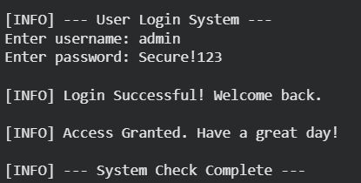
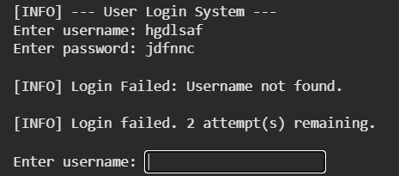

TESTING APPROACH

- Unit Testing: Manually verified that each function return the correct boolean and message for known inputs.
- Integration Testing: Verified that the entire chain works correctly by testing successful and unsuccessful login attempts.
- Boundary Testing: Checked edge cases like exactly 3 failed attempts, minimum password length, and blank inputs.

CHALLENGES FACED
- Circular Imports: Initial difficulty preventing modules import each other, which was solved by ensuring a strict, linear dependency path (main validation credentials).
- Complex Regex: Writing and debugging the regular expressions in is_password_secure to correctly validate all five security requirements simultaneously.
- Handling input(): Ensuring the CLI interface was robust against users entering non-standard characters or extra spaces.

LEARNINGS & KEY TAKEAWAYS

- Modularity is Key: The project successfully demonstrated that separating data logic

- Import Structure: A clear understanding of the Python module system and the hierarchy of imports is essential for large projects.
- Separation of Concerns: The single most important takeaway is the practice of having functions and modules focus

FUTURE ENHANCEMENTS
- Persistent Storage: Integrate a database or use JSON files to store and retrieve user data permanently.
- Password Hashing: Implement cryptographic hashing to securely store passwords instead of plain text.
- User Registration: Fully implement the registration process, allowing new valid users to be added to the persistent storage.

REFERENCES
https://docs.python.org/3/
https://docs.python.org/3/library/re.html
https://research.google.com/colaboratory/faq.htm
https://peps.python.org/pep-0008

